Experiment 7: Perceptron and Forward Propagation

1. Aim
To implement a single-layer perceptron using NumPy by performing weighted sum, bias addition and step activation. To train the perceptron on a synthetic loan approval dataset using the perceptron learning rule, record weight updates for each epoch, visualize the learned decision boundary, demonstrate the failure of a single perceptron to learn the XOR pattern, and compare step, sigmoid and ReLU activation functions using NumPy and Matplotlib.

2. Formula(s)
1. Weighted Sum: z = (w1 × x1) + (w2 × x2) + b
2. Step Activation Function: f(z) = 1, if z >= 0 f(z) = 0, if z < 0
3. Perceptron Learning Rule: Error = Actual Output - Predicted Output, w(new) = w(old) + α × Error × Input, b(new) = b(old) + α × Error
4. Sigmoid Activation Function: Sigmoid(z) = 1 / (1 + e^(-z))
5. ReLU Activation Function: ReLU(z) = max(0, z)
6. Decision Boundary: w1 × x1 + w2 × x2 + b = 0
3. Overall Flow Diagram
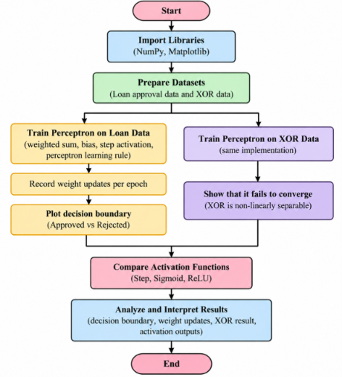

4. Code :

import numpy as np

import matplotlib.pyplot as plt

np.random.seed(42)

X = np.random.rand(100, 2)

y = (

0.65 * X[:, 0] + 0.35 * X[:, 1] >= 0.52

).astype(int)

weights = np.zeros(2)

bias = 0.0

learning_rate = 0.1

epochs = 30

weight_history = []

updates_history = []

def step_activation(z):

return 1 if z >= 0 else 0

for epoch in range(epochs):

updates = 0

for i in range(len(X)):

z = np.dot(X[i], weights) + bias

predicted = step_activation(z)

error = y[i] - predicted

if error != 0:

weights += learning_rate * error * X[i]

bias += learning_rate * error

updates += 1

weight_history.append(weights.copy())

updates_history.append(updates)

print(

f"Epoch {epoch+1}: "

f"Weights = {np.round(weights, 3)}, "

f"Bias = {bias:.3f}, "

f"Updates = {updates}"

)

if updates == 0:

break

predictions = (

X @ weights + bias >= 0

).astype(int)

accuracy = np.mean(predictions == y) * 100

print("\nFinal Weights:", np.round(weights, 3))

print("Final Bias:", round(bias, 3))

print("Training Accuracy:", round(accuracy, 2), "%")

plt.figure(figsize=(8, 6))

plt.scatter(

X[y == 0, 0], X[y == 0, 1],

color='red', label='Rejected'

)

plt.scatter(

X[y == 1, 0], X[y == 1, 1],

color='green', label='Approved'

)

x_line = np.linspace(0, 1, 100)

if abs(weights[1]) > 1e-10:

y_line = (

-weights[0] * x_line - bias

) / weights[1]

plt.plot(

x_line, y_line,

color='blue', label='Decision Boundary'

)

plt.xlabel("Credit Score")

plt.ylabel("Income-to-Debt Ratio")

plt.title("Perceptron Loan Approval Decision Boundary")

plt.xlim(0, 1)

plt.ylim(0, 1)

plt.legend()

plt.grid()

plt.show()

weight_history = np.array(weight_history)

plt.figure(figsize=(8, 5))

plt.plot(

range(1, len(weight_history) + 1),

weight_history[:, 0],

marker='o',

label='Weight 1'

)

plt.plot(

range(1, len(weight_history) + 1),

weight_history[:, 1],

marker='s',

label='Weight 2'

)

plt.xlabel("Epoch")

plt.ylabel("Weight Value")

plt.title("Weight Updates Per Epoch")

plt.legend()

plt.grid()

plt.show()

X_xor = np.array([

[0, 0],

[0, 1],

[1, 0],

[1, 1]

])

y_xor = np.array([0, 1, 1, 0])

xor_weights = np.zeros(2)

xor_bias = 0.0

xor_learning_rte = 0.1

xor_epochs = 20

print("\nXOR Perceptron Training:")

for epoch in range(xor_epochs):

errors = 0

for i in range(len(X_xor)):

z = np.dot(

X_xor[i], xor_weights

) + xor_bias

predicted = step_activation(z)

error = y_xor[i] - predicted

if error != 0:

xor_weights += (

xor_learning_rate * error * X_xor[i]

)

xor_bias += xor_learning_rate * error

errors += 1

print(

f"Epoch {epoch+1}: Errors = {errors}"

)

xor_predictions = (

X_xor @ xor_weights + xor_bias >= 0

).astype(int)

print("\nActual XOR Output:", y_xor)

print("Predicted XOR Output:", xor_predictions)

print(

"XOR Accuracy:",

np.mean(xor_predictions == y_xor) * 100,

"%"

)

print("Observation: Single perceptron cannot learn XOR.")

z = np.array([-2, -1, 0, 1, 2]

step_output = np.where(z >= 0, 1, 0)

sigmoid_output = 1 / (1 + np.exp(-z))

relu_output = np.maximum(0, z)

print("\nActivation Function Comparison")

print("Input:", z)

print("Step:", step_output)

print("Sigmoid:", np.round(sigmoid_output, 3))

print("ReLU:", relu_output)

plt.figure(figsize=(9, 5))

plt.plot(

z, step_output,

marker='o', label='Step'

)

plt.plot(

z, sigmoid_output,

marker='s', label='Sigmoid'

)

plt.plot(

z, relu_output,

marker='^', label='ReLU'

)

plt.xlabel("Input (z)")

plt.ylabel("Activation Output")

plt.title("Comparison of Activation Functions")

plt.legend()

plt.grid()

plt.show()

5. Output
Epoch 1: Weights = [0.292 0.152], Bias = -0.200, Updates = 22
Epoch 2: Weights = [0.347 0.232], Bias = -0.300, Updates = 13
Epoch 3: Weights = [0.393 0.206], Bias = -0.300, Updates = 2
Epoch 4: Weights = [0.393 0.206], Bias = -0.300, Updates = 0
Final Weights: [0.393 0.206]
Final Bias: -0.3
Training Accuracy: 100.0 %
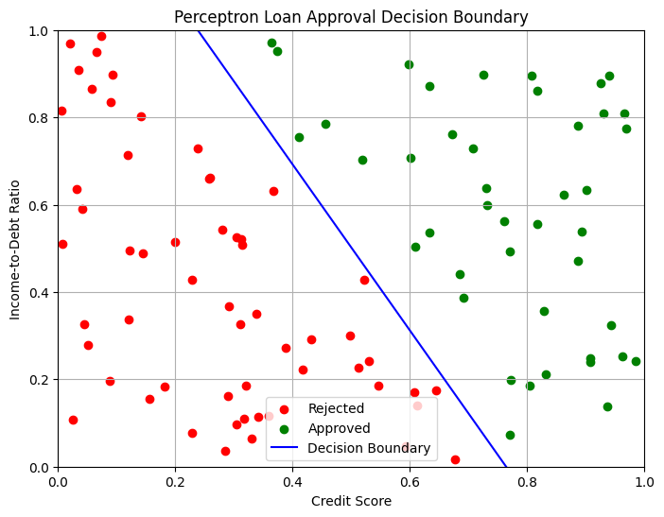
XOR Perceptron Training:
Epoch 1: Errors = 3
Epoch 2: Errors = 3
Epoch 3: Errors = 4
Epoch 4: Errors = 4
Epoch 5: Errors = 4
Epoch 6: Errors = 4
Epoch 7: Errors = 4
Epoch 8: Errors = 4
Epoch 9: Errors = 4
Epoch 10: Errors = 4
Epoch 11: Errors = 4
Epoch 12: Errors = 4
Epoch 13: Errors = 4
Epoch 14: Errors = 4
Epoch 15: Errors = 4
Epoch 16: Errors = 4
Epoch 17: Errors = 4
Epoch 18: Errors = 4
Epoch 19: Errors = 4
Epoch 20: Errors = 4
Actual XOR Output: [0 1 1 0]
Predicted XOR Output: [1 1 0 0]
XOR Accuracy: 50.0 %
Observation: Single perceptron cannot learn XOR
Activation Function Comparison
Input: [-2 -1 0 1 2]
Step: [0 0 1 1 1]
Sigmoid: [0.119 0.269 0.5 0.731 0.881]
ReLU: [0 0 0 1 2]
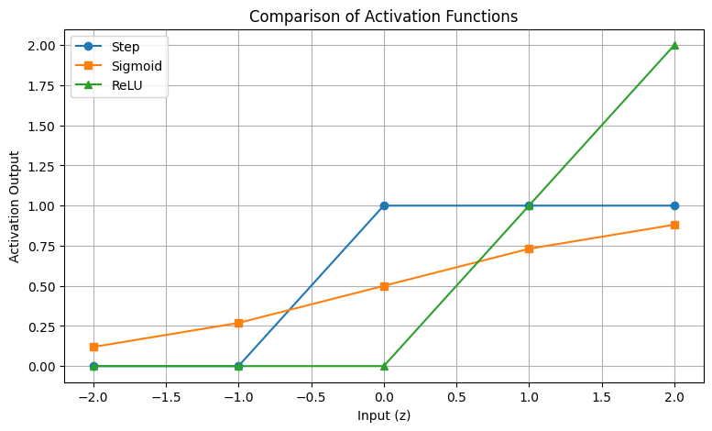

6. Result
A single-layer perceptron was successfully implemented using NumPy. The loan approval dataset achieved 100% training accuracy. The XOR experiment demonstrated that a single perceptron cannot learn non-linearly separable patterns. Step, sigmoid and ReLU activation functions were also compared and visualized successfully.

